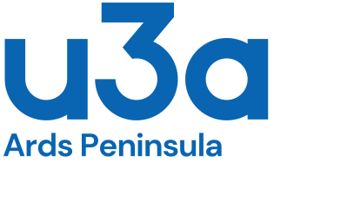
Membership Renewal 2024-25

Name: .................................................................................................................
(Name you wish to be known by)
Membership Number: …………………………….....................................................
(If you have forgotten your number, just leave blank)
- I wish to renew my membership of Ards Peninsula u3a for 2024-2025.
- I agree to the conditions of my original application.
- None of my details have changed.
- My decisions on Third Age Matters, photography and Gift Aid remain the same.

Please tick below to show how you are paying this year’s membership fee of £15:
Electronic Transfer
Your reference name............................................................................... to the account of:
Ards Peninsula u3a: Sort Code: 20 51 08 Account number: 30635383
OR
Attached Cash/Cheque (made payable to Ards Peninsula u3a).

Signed: …………………………………………………...
Date: ....................................................................................
Please return this form, with cash or cheque if appropriate, to: The Membership Secretary
Ards Peninsula u3a, PO Box 39, Donaghadee BT21 0ED

As a registered charity, we invite you to gift aid your membership fee, if you have not already agreed to this, by completing the Gift Aid authorisation overleaf.

Gift Aid Declaration
I confirm that I have paid or will pay an amount of Income Tax and/or Capital Gains Tax for each tax year (6 April to 5 April) that is at least equal to the amount of tax to be reclaimed on my charitable gifts. I understand that other taxes, e.g. VAT, do not qualify.
Please TICK to indicate that you agree
I am a UK tax payer and wish my subscription to Ards Peninsula u3a to be treated as a GIFT AID donation.

Members living at the same address can make declarations on the same form.
Member 1
Title | First name or initial
Surname
Signature |  | Date

Member 2
Title | First name or initial
Surname
Signature |  | Date

Please complete this form ONLY if you are a UK taxpayer and you wish to Gift Aid your subscription.
Please inform us if you:
- Cease paying income tax
- Change your name or address
- Wish to stop paying Gift Aid

Thank You

Northern Ireland Charity Number: 108953

